实验报告
2020 年 6 月 6 日 成绩：
姓名 | 易永豪 | 学号 | 17052247 | 班级 | 17052315
专业 | 计算机科学与技术 |  | 课程名称 | 《数字电路与硬件描述语言》
任课老师 | 张翔 | 指导老师 | 张翔 | 机位号
实验序号 | 8 | 实验名称 | R型
实验时间 | 2020.6.6 | 实验地点 | 1教215 | 实验设备号
一、实验程序源代码
- 模块设计说明
一共有6个模块：顶层测试模块；顶层控制模块；数码管显示模块；寄存器堆模块；ALU模块；PC指令模块
- 实验程序源代码及注释等
实验有5个模块，一个顶测试模块（用LED灯显示），一个CPU模块，还有寄存器堆模块、ALU模块、取指令模块
//顶层测试模块
module TOP8(rst,clk,choose,LED);
input rst,clk;
input choose;
output reg [31:0]LED;
wire ZF,OF;
wire [31:0]F;
CPU c(rst,clk,ZF,OF,F);
always@(*)
begin
case(choose)
1'b0: LED=F[31:0];
1'b1:begin LED[1]=OF;LED[0]=ZF;LED[31:2] = 30'D0;end
endcase
end
endmodule

//CPU模块
module CPU(
input rst,
input clk,
output ZF,
output OF,
output [31:0]F
);
reg write_reg;
wire [31:0]Inst;
wire [31:0]R_Data_A;
wire [31:0]R_Data_B;
reg [2:0]ALU_OP;

//调用取指令模块，寄存器堆模块，ALU模块

QZL f(rst,clk,Inst);

Register r(
Inst[25:21],//rd
Inst[20:16],//rs
Inst[15:11],//rt
write_reg,
F,clk,rst,R_Data_A,R_Data_B);

ALU alu(R_Data_A,R_Data_B,F,ALU_OP,ZF,OF);

always@(*) //译码与存储单元模块
begin
write_reg=0; //初始化为读信号
ALU_OP=0;
if(Inst[31:26]==0)//OP=000000 R指令
begin
case(Inst[5:0]) //根据Inst[5:0]选择ALU_OP
6'b100000:ALU_OP=3'b100;
6'b100010:ALU_OP=3'b101;
6'b100100:ALU_OP=3'b000;
6'b100101:ALU_OP=3'b001;
6'b100110:ALU_OP=3'b010;
6'b100111:ALU_OP=3'b011;
6'b101011:ALU_OP=3'b110;
6'b000100:ALU_OP=3'b111;
endcase
write_reg=1; //改为写信号
end
end
endmodule

//取指令模块
module QZL( //PC及自增电路
input rst,
input clk,
output [31:0]Inst
);
wire [31:0]PC_new;
reg [31:0]PC;
initial
PC=32'h00000000;
ROM_B inst(
.clka(clk),
.addra(PC[7:2]),
.douta(Inst)
);
assign PC_new=PC+4;
always@(posedge rst or negedge clk)
begin
if(rst)
PC=32'h00000000;
else
PC={24'h000000,PC_new[7:0]};
end
endmodule

//寄存器堆模块
module Register(input [4:0]R_Addr_A,
input [4:0]R_Addr_B,
input [4:0]W_Addr,
input Write_Reg,
input [31:0]W_Data,
input Clk,
input Reset,
output [31:0]R_Data_A,
output [31:0]R_Data_B
);
reg [31:0]REG_Files[0:31];
reg [5:0]i;
initial
begin
for(i=0;i<=31;i=i+1)
REG_Files[i]=0;
end
assign R_Data_A=REG_Files[R_Addr_A];
assign R_Data_B=REG_Files[R_Addr_B];
always@(posedge Clk or posedge Reset)
begin
if(Reset)
for(i=0;i<=31;i=i+1)
REG_Files[i]=0;
else
if(Write_Reg && W_Addr!=0)
REG_Files[W_Addr]=W_Data;
end
endmodule

//ALU模块
module ALU(A,B,F,ALU_OP,ZF,OF);
input [31:0]A,B;
input [2:0]ALU_OP;
output reg ZF,OF;
output reg [31:0]F;
reg C32;
always@(*)
begin
OF=1'b0;
C32=1'b0;
case(ALU_OP)
3'b000:F=A&B;
3'b001:F=A|B;
3'b010:F=A^B;
3'b011:F=~(A|B);
3'b100:begin {C32,F}=A+B;OF=A[31]^B[31]^F[31]^C32; end
3'b101:begin {C32,F}=A-B;OF=A[31]^B[31]^F[31]^C32; end
3'b110: if(A<B)
F=1;
else
F=0;
3'b111:F=B<<A;
endcase
if(F==0)
ZF=1;
else
ZF=0;
end
endmodule

二、仿真波形
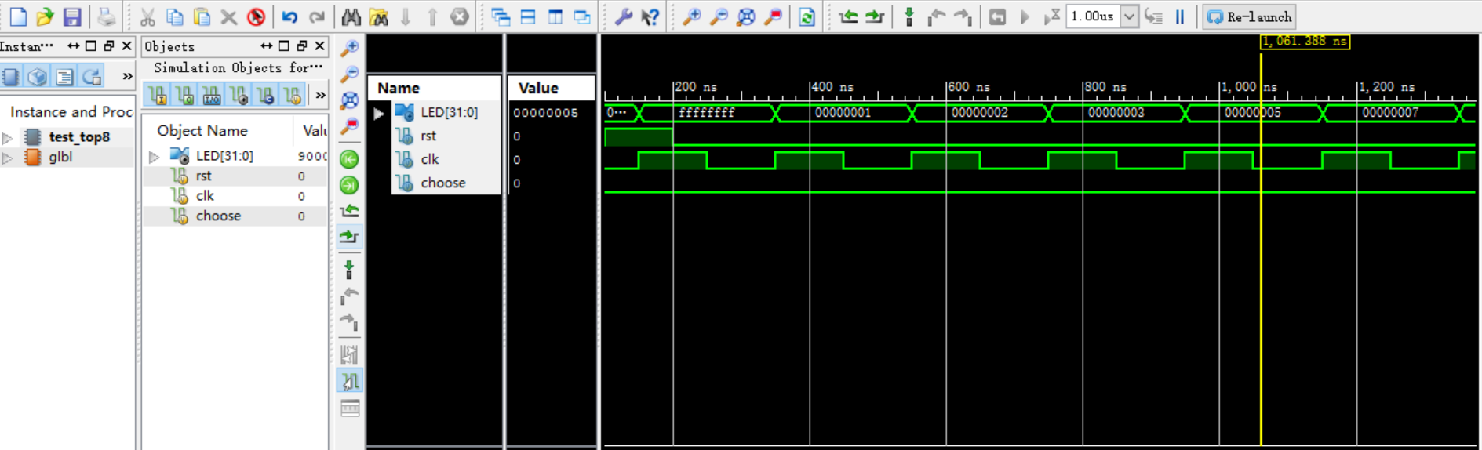
- 仿真结果分析
$1=FFFF_FFFF | $16=FFFF_FFF0
$2=0000_0001 | $17=0000_0010
$3=0000_0002 | $18=7000_0000
$4=0000_0003 | $19=0002_0000
$5=0000_0005 | $20=8000_0000
$6=0000_0007 | $21=7FFF_FFFF
$7=0000_000E | $22=7FFF_FFFF
$9=0000_000C | $23=FFFF_FFFF
$8=0000_7000 | $24= 0000_0001
$9=FFFF_8FFF | $25=FFFF_FFFF
$10= FFFF_8FFE | $26=8FFF_FFFF
$11=0000_6FF2 | $27=0000_0001
$12=FFFF_900E | $28=0000_0000
$13=FFFF_800E | $29=8000_0000
$14=FFFF_9FFFF | $30=7FFF_FFFF
$15=0000_000F | $30=9000_6FF1

三、电路图
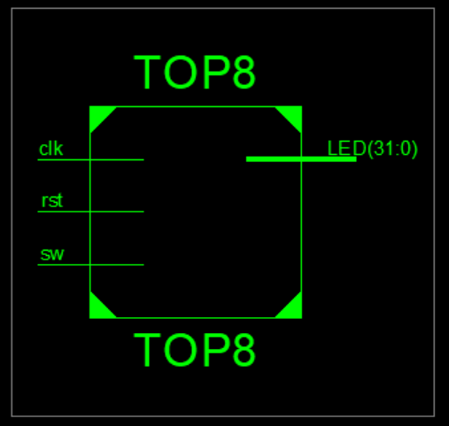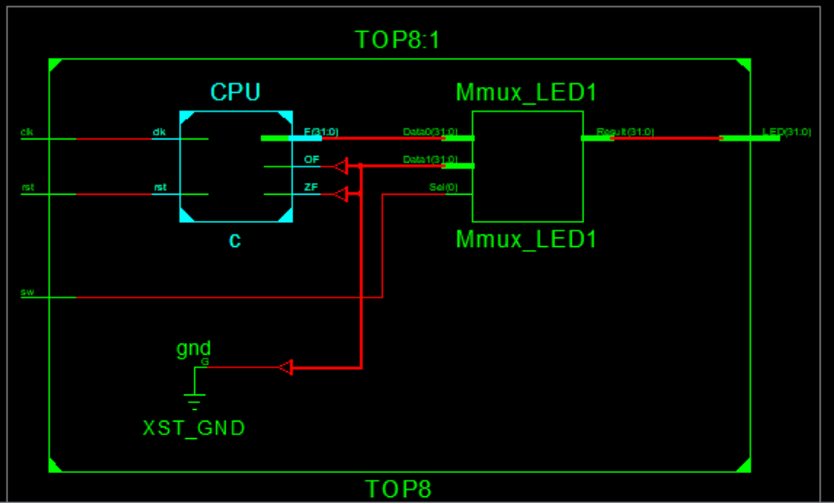
四、引脚配置（约束文件）
NET "clk" LOC="R4"|IOSTANDARD=LVCMOS18;
NET "rst" LOC="AA4"|IOSTANDARD=LVCMOS18;
NET "choose" LOC="AB6"|IOSTANDARD=LVCMOS18;
NET "LED[31]" LOC="R1"|IOSTANDARD=LVCMOS18;
NET "LED[30]" LOC="P2"|IOSTANDARD=LVCMOS18;
NET "LED[29]" LOC="P1"|IOSTANDARD=LVCMOS18;
NET "LED[28]" LOC="N2"|IOSTANDARD=LVCMOS18;
NET "LED[27]" LOC="M1"|IOSTANDARD=LVCMOS18;
NET "LED[26]" LOC="M2"|IOSTANDARD=LVCMOS18;
NET "LED[25]" LOC="L1"|IOSTANDARD=LVCMOS18;
NET "LED[24]" LOC="J2"|IOSTANDARD=LVCMOS18;
NET "LED[23]" LOC="G1"|IOSTANDARD=LVCMOS18;
NET "LED[22]" LOC="E1"|IOSTANDARD=LVCMOS18;
NET "LED[21]" LOC="D2"|IOSTANDARD=LVCMOS18;
NET "LED[20]" LOC="A1"|IOSTANDARD=LVCMOS18;
NET "LED[19]" LOC="L3"|IOSTANDARD=LVCMOS18;
NET "LED[18]" LOC="G3"|IOSTANDARD=LVCMOS18;
NET "LED[17]" LOC="K4"|IOSTANDARD=LVCMOS18;
NET "LED[16]" LOC="G4"|IOSTANDARD=LVCMOS18;
NET "LED[15]" LOC="K1"|IOSTANDARD=LVCMOS18;
NET "LED[14]" LOC="J1"|IOSTANDARD=LVCMOS18;
NET "LED[13]" LOC="H2"|IOSTANDARD=LVCMOS18;
NET "LED[12]" LOC="G2"|IOSTANDARD=LVCMOS18;
NET "LED[11]" LOC="F1"|IOSTANDARD=LVCMOS18;
NET "LED[10]" LOC="E2"|IOSTANDARD=LVCMOS18;
NET "LED[9]" LOC="D1"|IOSTANDARD=LVCMOS18;
NET "LED[8]" LOC="B1"|IOSTANDARD=LVCMOS18;
NET "LED[7]" LOC="B2"|IOSTANDARD=LVCMOS18;
NET "LED[6]" LOC="N3"|IOSTANDARD=LVCMOS18;
NET "LED[5]" LOC="M3"|IOSTANDARD=LVCMOS18;
NET "LED[4]" LOC="K3"|IOSTANDARD=LVCMOS18;
NET "LED[3]" LOC="H3"|IOSTANDARD=LVCMOS18;
NET "LED[2]" LOC="N4"|IOSTANDARD=LVCMOS18;
NET "LED[1]" LOC="L4"|IOSTANDARD=LVCMOS18;
NET "LED[0]" LOC="J4"|IOSTANDARD=LVCMOS18;

NET "LED[31]" PULLDOWN;
NET "LED[30]" PULLDOWN;
NET "LED[29]" PULLDOWN;
NET "LED[28]" PULLDOWN;
NET "LED[27]" PULLDOWN;
NET "LED[26]" PULLDOWN;
NET "LED[25]" PULLDOWN;
NET "LED[24]" PULLDOWN;
NET "LED[23]" PULLDOWN;
NET "LED[22]" PULLDOWN;
NET "LED[21]" PULLDOWN;
NET "LED[20]" PULLDOWN;
NET "LED[19]" PULLDOWN;
NET "LED[18]" PULLDOWN;
NET "LED[17]" PULLDOWN;
NET "LED[16]" PULLDOWN;
NET "LED[15]" PULLDOWN;
NET "LED[14]" PULLDOWN;
NET "LED[13]" PULLDOWN;
NET "LED[12]" PULLDOWN;
NET "LED[11]" PULLDOWN;
NET "LED[10]" PULLDOWN;
NET "LED[9]" PULLDOWN;
NET "LED[8]" PULLDOWN;
NET "LED[7]" PULLDOWN;
NET "LED[6]" PULLDOWN;
NET "LED[5]" PULLDOWN;
NET "LED[4]" PULLDOWN;
NET "LED[3]" PULLDOWN;
NET "LED[2]" PULLDOWN;
NET "LED[1]" PULLDOWN;
NET "LED[0]" PULLDOWN;

NET "clk" CLOCK_DEDICATED_ROUTE = FALSE;
NET "rst" CLOCK_DEDICATED_ROUTE = FALSE;
五、思考与探索
- 实验结果记录：与前面仿真结果一致
$1=FFFF_FFFF | $16=FFFF_FFF0
$2=0000_0001 | $17=0000_0010
$3=0000_0002 | $18=7000_0000
$4=0000_0003 | $19=0002_0000
$5=0000_0005 | $20=8000_0000
$6=0000_0007 | $21=7FFF_FFFF
$7=0000_000E | $22=7FFF_FFFF
$9=0000_000C | $23=FFFF_FFFF
$8=0000_7000 | $24= 0000_0001
$9=FFFF_8FFF | $25=FFFF_FFFF
$10= FFFF_8FFE | $26=8FFF_FFFF
$11=0000_6FF2 | $27=0000_0001
$12=FFFF_900E | $28=0000_0000
$13=FFFF_800E | $29=8000_0000
$14=FFFF_9FFFF | $30=7FFF_FFFF
$15=0000_000F | $30=9000_6FF1
不过在7FFF_FFFF时，有溢出，OF=1
- 实验结论：
板级验证与实验结果一致，实验正确
- 问题与解决方案：
clk和reset的上下跳沿没有弄清楚，后来老师帮忙改正了
- 思考题：
1)将测试程序（≥16条）的各条指令执行的结果和标志记 录到表14.19中，分析结果正确与否？如果不正确，请分析原因。
序号 | 指令 | 执行结果 | 标志（ZF OF） | 结论
1 | 00000827 | FFFF_FFFF | 0 0 | 正确
2 | 0001102b | 0000_0001 | 0 0 | 正确
3 | 00421820 | 0000_0002 | 0 0 | 正确
4 | 00622020 | 0000_0003 | 0 0 | 正确
5 | 00832820 | 0000_0005 | 0 0 | 正确
6 | 00a33020 | 0000_0007 | 0 0 | 正确
7 | 00463804 | 0000_000E | 0 0 | 正确
8 | 00a64820 | 0000_000C | 0 0 | 正确
9 | 01264004 | 0000_7000 | 0 0 | 正确
10 | 00284826 | FFFF_8FFF | 0 0 | 正确
11 | 01215020 | FFFF_8FFE | 0 0 | 正确
12 | 01075822 | 0000_6FF2 | 0 0 | 正确
13 | 00e86022 | FFFF_900E | 0 0 | 正确
14 | 012c6824 | FFFF_800E | 0 0 | 正确
15 | 012c7025 | FFFF_9FFF | 0 0 | 正确
16 | 00c77825 | 0000_FFFF | 0 0 | 正确
由表格可以看出，结果正确。

